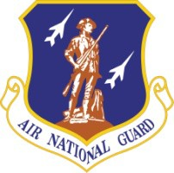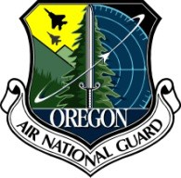FACT SHEET

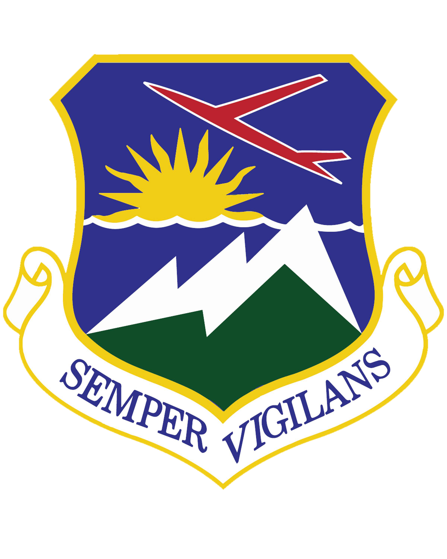

**U.S. Air National Guard Fact Sheet**

History of the 142nd Wing (revised version 13 March 2025)

The history of the 142nd Wing began at Richmond Army Air Base, Virginia, on 15 July 1943 when the 371st Fighter Group was activated. The group trained in the Republic P-47 Thunderbolt fighter, deployed to Great Britain in March, 1944 and commenced combat operations in April over occupied Northwestern Europe.

The 371st flew in support of the Allied landings on D-Day, June 6, 1944 and the subsequent breakout from Normandy. It then supported General George S. Patton Jr.’s epic drive across France and in March, 1945 his Third Army’s approach and crossing of the Rhine River. In late 1944 / early 1945 the group conducted operations which enabled Allied ground forces which had landed in southern France to reach the German border. This included a unique series of missions to help the “Lost Battalion” hold out against enemy forces. In these campaigns the group operated from two airfields in Great Britain, six in France, two in Germany and one in Austria, mostly in an austere, expeditionary setting.

During the war the group expended 4,167 tons of bombs and 5,390,321 rounds of .50-caliber machine gun ammunition. Unit P-47 pilots were officially credited with 62.50 aerial victories. Some 50 group members, mostly pilots, were killed in wartime service - another five remain missing. Over 20 pilots were shot down, captured and became prisoners of war (POW).

After 13 months of combat, the group was awarded a Distinguished Unit Citation (Presidential Unit Citation today; the highest level of unit award) for actions in Germany between 15 – 21 March 1945. It received credit for participation in six military campaigns and was cited in the Belgian Army Order of the Day for combat operations between 6 June and 17 September 1944.

Postwar the group served in occupation duty in Germany and Austria before returning to the U.S for inactivation on 10 November 1945. But as part of the post-World War II buildup of the air component of the National Guard, many inactivated combat groups with distinguished records were renumbered with National Guard 100-series numbers and allotted to the various states. On 24 May 1946, the 371st Fighter Group was redesignated as the 142nd Fighter Group and allotted to the state of Oregon to continue the lineage established and honors achieved by the 371st FG - it is actually the same unit, just renumbered.

The 142nd FG began fighter operations At Portland Air Base, Oregon in the North American P-51D Mustang with 75 officers and 800 enlisted men. Beginning on 1 March 1951, the group mobilized in response to the Korean War. Group headquarters deployed from Portland to O’Hare International Airport, Illinois from 11 April 1951 where it directed fighter-interceptor operations in the region as part of a buildup of continental air defense forces. The group was redesignated 142nd Fighter-Interceptor Group (FIG) in April, 1951. It was during this stint on active duty that the group’s distinctive emblem and motto “Semper Vigilans” (Always on Guard) were officially approved.

Subordinate units of the group were also fully caught up in the Korean mobilization but served at other locations stateside and overseas. Some pilots from the group’s 123rd Fighter Squadron were activated and flew F-51D Mustang fighters in combat – Oregon’s fighter pilots flew 1,051 sorites, dropped 1,056 bombs, fired 3,715 rockets, dropped 456 napalm bombs and expended 1,194,000 rounds of .50-caliber machine gun ammunition during their combat tours. They claimed one enemy aircraft destroyed and two more damaged. Group HQ was inactivated at O’Hare on 6 February 1952 and remained so until return to Oregon and reactivation at Portland on 1 December 1952.

After the Korean conflict the 142nd FIG served in the air defense role in Pacific Northwest through the Cold War years. In 1958, the 142nd began standing 24-hour air defense alert which continues to this day. The unit served under the USAF’s Air (later Aerospace) Defense Command (ADC) and then in 1980 the Tactical Air Command (TAC); since 1958 it’s served under the combined/joint North American Air (later Aerospace) Defense Command (NORAD).

In 1976 the unit won top honors at a pair of major ADC competitions, the Weapons Loading Competition and the F-101 category at the famous William Tell World Wide Weapons Meet. Success came again at William Tell 1984 when the unit placed first in the F-4 category flying the McDonnell Douglas F-4C Phantom II and beat many of its F-15 Eagle and F-106 Delta Dart rivals in the overall competition. In the 50th Year of William Tell Anniversary Competition held in 2004, the 142nd FW was rated first in Maintenance, Element Attack and Gun categories. These William Tell successes demonstrate Oregon's long history of excellence and readiness to accomplish the real-world mission.

With the McDonnell Douglas F-4C Phantom II, the unit expanded its mission capability to include air superiority. Members were called to serve in this capacity in a Cold War deployment to Ramstein Air Base in West Germany in 1985-86 in Operation Creek Klaxon.

Since the end of the Cold War, the 142nd serves as the principal air defense unit in the greater Pacific Northwest. In 1992, as part of a large USAF reorganization, the group was redesignated yet again as the 142nd Fighter Group and aligned under Air Combat Command (ACC). In 1995 the group was redesignated as the 142nd Fighter Wing (FW).

The wing participated in many expeditionary and humanitarian assistance missions in the turbulent post-Cold War environment while providing air defense of the greater Pacific Northwest. These included major deployments to Turkey in 1998 for Operation NORTHERN WATCH and to Saudi Arabia in 2000 for Operation SOUTHERN WATCH, patrolling the no-fly zones then in place over Iraq. The wing deployed aircraft to Panama in 1998 in support of counterdrug missions, stemming the flow of the drug trade by air. Aircraft and personnel also deployed to Iceland several times in support of North Atlantic Treaty Organization (NATO) commitments. Wing personnel deployed on various other missions, sending medical Airmen to Belize, civil engineers to Macedonia, and others to such places around the globe as Curacao, Denmark, Germany, Guam, Kuwait, Spain, and the United Kingdom.

On September 11, 2001 the wing was one of the first air defense units to respond to the terrorist attacks on the east coast with a rapidly increased air defense posture to enhance security on the west coast. The unit then began participation in Operation NOBLE EAGLE, the national military response to homeland defense. In 2004, wing personnel provided humanitarian aid in the wakes of Hurricanes Katrina and Rita and the 2007 floods in Vernonia, Oregon. The wing also supported ongoing contingency operations in Southwest Asia, including Operations IRAQI FREEDOM and ENDURING FREEDOM, such as in the 2004 deployment of medical personnel to Qatar, the 2009 deployment of security forces to Iraq and the 2014 deployment of civil engineers to Afghanistan and Bahrain.

While maintaining a constant Aerospace Control Alert (ACA) posture at home station, the 142nd FW accomplished myriad Air Expeditionary Force taskings.  In addition to contingency operations in SW Asia, F-15 aircraft and personnel deploy overseas when required, such as to the United Arab Emirates in 2010 for Exercise IRON FALCON.  In 2015 unit F-15s and personnel deployed as part of a Theater Support Package (TSP) to Romania for Operation ATLANTIC RESOLVE and another TSP for this operation to Bulgaria in 2018.

In October, 2015 the wing increased its mission scope when the 116th Air Control Squadron, 125th Special Tactics Squadron and 123d Weather Flight were assigned. This change added missions of aerospace command and control/air battle management and battlefield Airmen (combat controllers, pararescue, combat support and combat weather). Of note, select wing personnel are also members of Oregon’s joint Chemical-Biological-Radiological-Nuclear and high-yield Explosives (CBRNE) Enhanced Response Force Package (CERFP) team along with select Oregon Army Guard personnel. As a result of the gain of these new mission capabilities, the wing was redesignated as the 142nd Wing in 2020.

Since the unit received its first Air Force Outstanding Unit Award (AFOUA) in 1970, it has been recognized as such a total of nine more times, with the latest award given for outstanding performance of the mission from 1 October 2016 to 30 September 2018.

From its initial activation the 142nd Wing has flown high-performance fighter planes as the primary aircraft assigned, including the P-47D Thunderbolt (as 371st FG in WWII), P-51D/F-51D Mustang, F-86A/F Sabre, F-94B, F-89D/H/J Scorpion, F-102A Delta Dagger, F-101B Voodoo, F-4C Phantom II and a variety of operational support aircraft.  The wing has operated various and improved versions of the F-15A/C Eagle since 1989, and in June, 2024 became the first operational unit in the combat air forces to receive the new F-15EX Eagle II.

Today the members of the 142nd Wing are proud to continue service as a vital part of the Total Force team, defending our nation with the latest version of the F-15C Eagle, providing both continuous air defense and air superiority capabilities, as well as furnish air battle management, battlefield Airmen and CBRNE expertise. With more than 1,000 officers and airmen, the wing lives up to its motto, guarding the greater Pacific Northwest skies from northern California to the Canadian border, on ACA alert as part of ACC and NORAD. The 142nd Wing also stands ready to participate in state and federal contingency and expeditionary missions as required.

(Current as of 13 March 2025)

Oregon Air National Guard, 142nd Wing | 6801 N.E. Cornfoot Road, Building 142 | Portland Air National Guard Base, Portland, Ore. 97218 | (503) 335-4347 | DSN 638-4347 | [https://www.142wg.ang.af.mil/](http://www.142wg.ang.af.mil/)